***Lyddie***

***Chapter 20 – B is for Brigid***

Brigid was soon in charge of two looms and would stand in between both of them running back and forth.  Brigid worked very hard and was quickly becomming a good worker.

Lyddie continued to work.  When she would see Mr. Marsden they would make eye contact but act as if they barely knew one another.

Lyddie decided she had been working so hard she deserved to buy herself a present.  Lyddie bought herself another book called [Narrative of the Life of Frederick Douglass: An American Slave Writen by Himself.](http://bookbuilder.cast.org/view_glossary.php?book=111934&word=86943#curr)   She decided to buy this book in order to learn more about Ezekial's life and story.

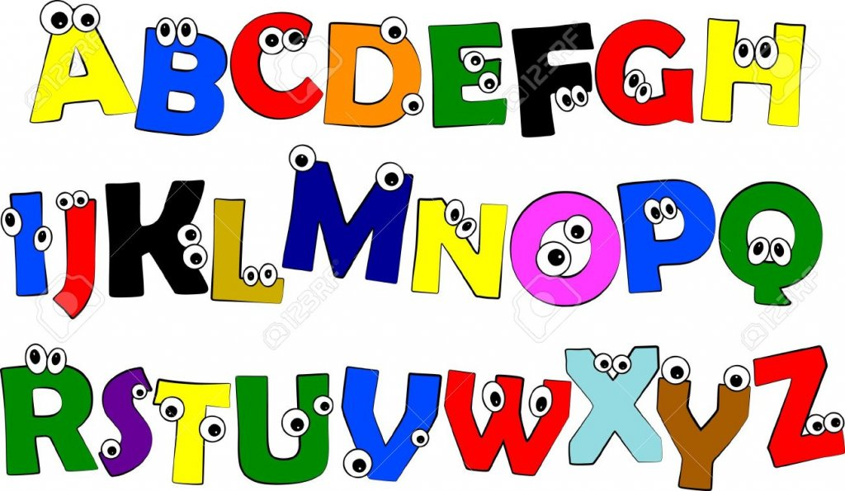

Soon, some of the other girls started to go home and Brigid was able to take on three looms.  Brigid even helped Lyddie train some of the other new girls.  Lyddie noticed how good Brigid was at teaching the other girls.  She was very kind and patient.

One day, Lyddie was talking to Brigid and realized that Brigid did not know how to read.  Lyddie decided to help teach her the letters and sounds by writing up papers for her to look at while she worked.



A few days later, Lyddie got a letter from Charlie.  It said:

Dear Sister Lyddie,

We are fine.  We hope you are well, too.  Rachel began school last month.  Her cough is almost gone and she is gaining weight because we eat well here.  Luke Stevens says you have not given him an answer yet on whether or not you will marry him.  Please think about it.  He is a good man.

Love,

Charlie

Lyddie almost ripped up the letter when she read the last part.  Why did everyone think she needed to get married??



It was now September and Lyddie was working at the factory when she got a letter in the mail that said, "We regret to inform you of the death of your mother".  Lyddie was sad, but she had not seen her mother in so long that she could not feel too sad about it.



As the days went on, Lyddie became closer friends with Brigid.  They would walk to eat meals together everyday.  One day, however, Lyddie was waiting for Brigid on the stairs, but she never came.  Lyddie waited until the stairs were clear of people and when she still did not see Brigid she went to look for her.

Lyddie was walking through the dark weaving room when she hear Brigid calling out "Please, don't Mr. Marsden!".  Lyddie grabbed a bucket of water that was laying on the ground (usually used to put out fires) and ran to where she heard Brigid yelling.  Lyddie saw Mr. Marsden with his hands on Brigid and Lyddie yelled for him to let go.  Then, she poured the bucket on his head, grabbed Brigid and ran for the door.

As Lyddie ran away pulling Brigid by the hand, she couldn't help but start laughing.  Brigid, however, looked afraid and confused.

When chapter 20 begins, [Lyddie](https://www.enotes.com/topics/lyddie?en_action=hh_answer_body_click&en_label=%2Fhomework-help%2Fwhat-summary-chapter-20-lyddie-638946%23answer-901545&en_category=internal_campaign) is working at her looms but remains wary of Mr. Marsden. She is worried that he would find some reason to have her fired, but they seem to have settled on just ignoring each other. Just to be safe, Lyddie makes sure that she follows every rule and regulation.

To help pass the time when she is not at the mill, Lyddie begins to read more. She begins the abolitionist work, Narrative of the Life of Frederick Douglass. Along with the Bible, reading these books bring much peace to Lyddie, and they are an encouraging distraction from the grueling and dangerous labor at the factory.

As the summer goes along, Lyddie takes up more work. Many of the New England girls have gone home for the summer. They are replaced by more immigrants from Ireland. To keep her spirits up, Lyddie attaches passages from her books to her loom. Lyddie and Brigid train many of the new workers. Lyddie notices how much more patient Brigid is with the new girls than she ever was.

Throughout the hot summer, Lyddie and Brigid grow closer. Lyddie takes to teaching Brigid to read, one letter at a time. She affixes each letter of the alphabet to Brigid's looms for her to study as they work. They spend their free time at lessons as well.

Toward the end of the summer, Lyddie receives a letter from Charles. He tells Lyddie that they have begun school. Rachel's chronic cough is nearly gone, and she is putting on weight.

By September, some of the New England girls have returned, but most of the workers are still Irish immigrants. Lyddie holds out hope that Diana will return, but she never does. That month, Lyddie receives a very formal letter informing her that her mother has died. Lyddie notes that she can barely remember what her mother looked like anymore.

As fall comes, the days become shorter, and the factory is lit by whale-oil lamps. Fire is a constant worry. Buckets of water are left out in case of a fire. Brigid is coming along well in learning to read and write, and the two girls spend a lot of time together.

One evening, Lyddie cannot find Brigid as normal. She goes to look for her friend and finds her still in the factory. Brigid is being forcefully held down by Mr. Marsden. She is pleading to be let go, but the foreman continues to assault her. Instinctively, Lyddie picks up a water bucket and slams it down over his head. Lyddie grabs Brigid, and they make their escape. As Mr. Marsden struggles with the bucket, Lyddie is reminded of the incident with the bear and the oatmeal pot from Cchapter 1. The recollection and the stress of the situation drive Lyddie to uncontrollable laughter.